1.Create a table named Playlists with columns: id, user_id, playlist_name, and total_likes. Insert at least 8 sample rows with different users and playlists, making sure some playlists have the same user_id.

CREATE TABLE Playlists (
id INT PRIMARY KEY,
user_id INT,
playlist_name VARCHAR(255),
total_likes INT
);
INSERT INTO Playlists (id, user_id, playlist_name, total_likes)
VALUES
(1, 101, 'Bollywood Hits', 1500),
(2, 101, 'Chill Vibes', 2500),
(3, 102, 'Workout Mix', 3000),
(4, 102, '90s Nostalgia', 1800),
(5, 103, 'Arijit Singh Top 20', 4500),
(6, 103, 'Party Anthems', 2500),
(7, 101, 'Study Lo-Fi', 800),
(8, 102, 'Road Trip', 3000);

2.Write a SQL query using ROW_NUMBER() and the OVER() clause to assign a unique row number to each playlist, ordered by total_likes in descending order.

SELECT
id, user_id, playlist_name, total_likes,
ROW_NUMBER() OVER(ORDER BY total_likes DESC) AS row_num
FROM Playlists;

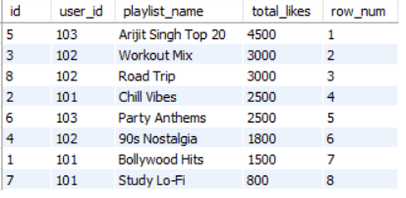

3.Use the RANK() function with the OVER() clause to rank all playlists by total_likes, and display the playlist_name, user_id, total_likes, and their rank.

SELECT
playlist_name, user_id, total_likes,
RANK() OVER(ORDER BY total_likes DESC) AS playlist_rank
FROM Playlists;

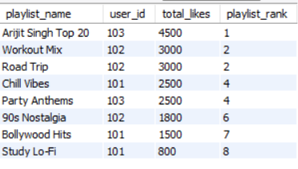

4.Write a SQL query using DENSE_RANK() and PARTITION BY user_id to rank each user's playlists by total_likes, showing playlist_name, user_id, total_likes, and dense rank.<br><br><em><strong>Hint:</strong> This will show how popular each playlist is within each user's account, similar to how Spotify might rank your top playlists.</em>

SELECT
playlist_name, user_id, total_likes,
DENSE_RANK() OVER(PARTITION BY user_id ORDER BY total_likes DESC) AS user_dense_rank
FROM Playlists;
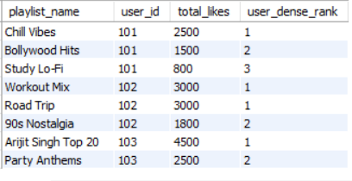
5.Imagine you want to show the top 2 playlists per user based on total_likes, like Spotify's 'Your Top Playlists' feature. Write a query using a window function to select only the top 2 playlists for each user.

WITH RankedPlaylists AS (
SELECT
playlist_name,
user_id,
total_likes,
ROW_NUMBER() OVER(PARTITION BY user_id ORDER BY total_likes DESC) AS top_playlist_rank
FROM Playlists
)
SELECT playlist_name, user_id, total_likes
FROM RankedPlaylists
WHERE top_playlist_rank <= 2;

